FedEx – Setup Export/Import Connections

Setup Mapped Drive
Go to Integration > FedEx Integration Assistant
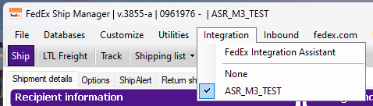
Create a new profile, Continue
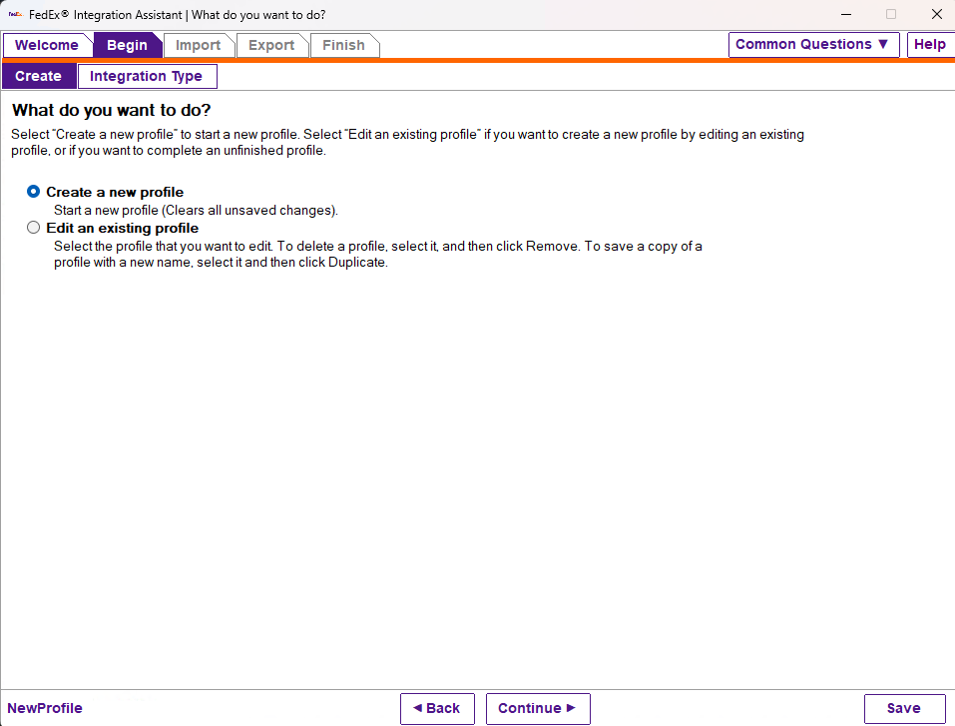

Create Both Import and Export, no LTL Freight Profile, Continue.
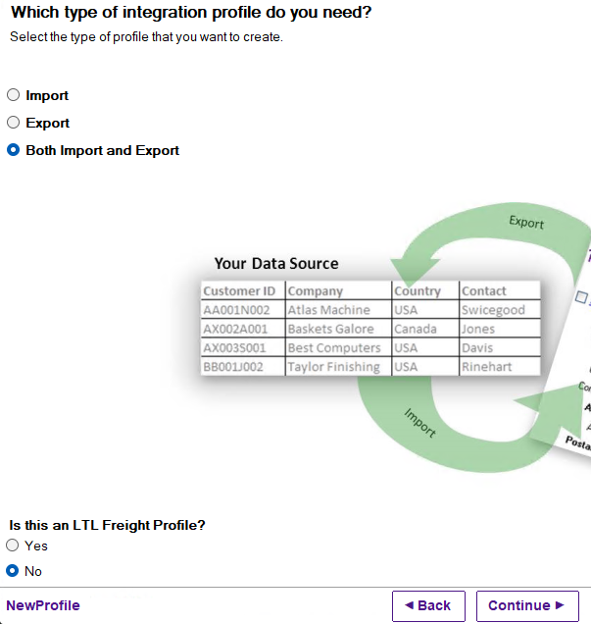
Pick ODBC for Import
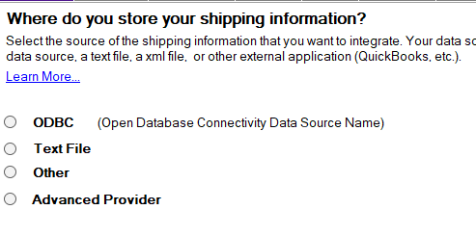
Select the ODBC DSN you created in the prior step and Continue
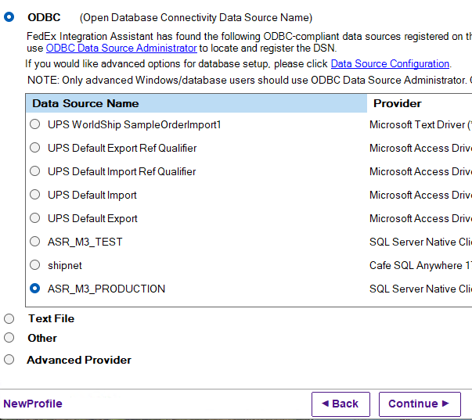
You’ll get a message about not being able to connect, click OK and it will prompt for credentials, enter the credentials from the ODBC setup step and click Ok.
User: SM0004
Password: <Ask Development Team for Password – in Key Vault>
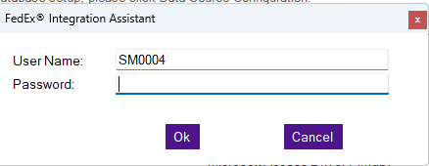

Answer the questions the following way and hit Continue.
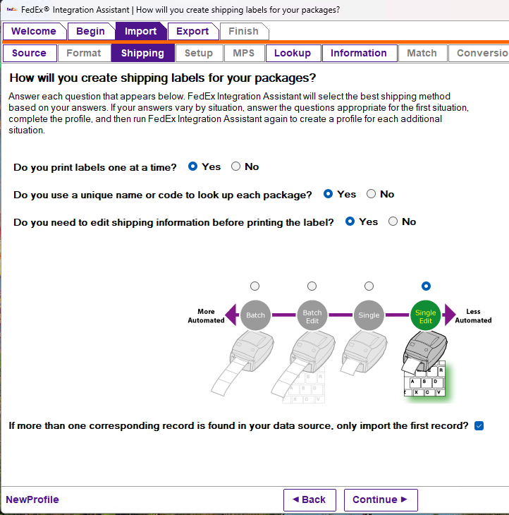

Select the choices as shown below and click continue.
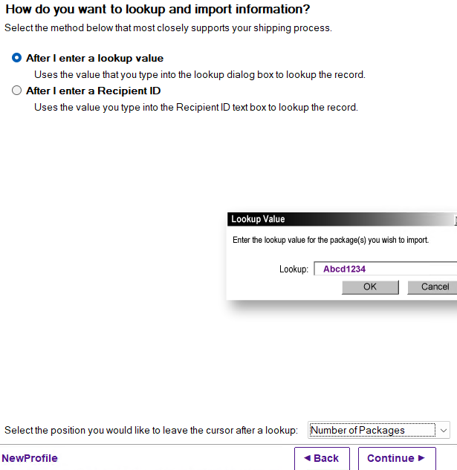
We’re going to map fields to Recipient and Package.
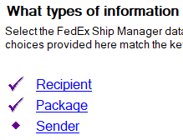
On Recipient we need the following fields
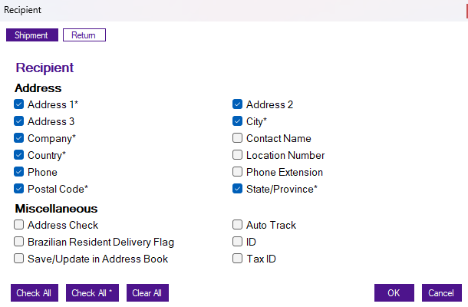
On Package, the following fields, it scrolls but only the three are checked.
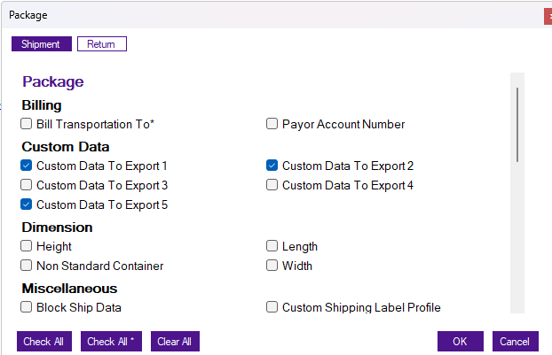
Select the table (view) vw_fedex_ups_address_query
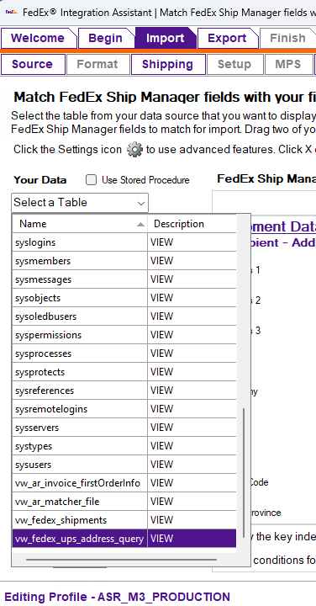
Recipient should be mapped as follows. It will warn you the field your mapping is longer, that is ok – check don’t show again and continue mapping.
Country = ship_to_country
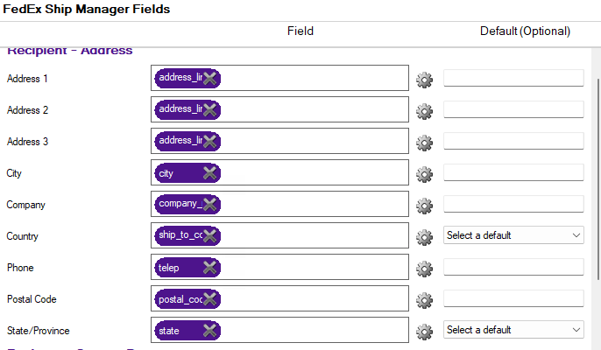

Package fields as follows:
Custom Data to Export 1 = order_number
Custom Data to Export 2 = customer_po_number
Custom Data to Export 5 = delivery_number
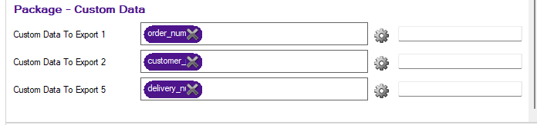

You’ll get a dialog for setting the primary key, set it to delivery_number
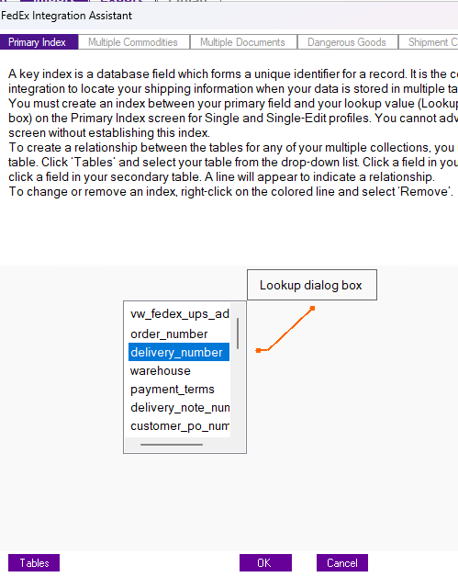
DONE WITH IMPORT!!!

Integration – Export
Select ODBC and your connection
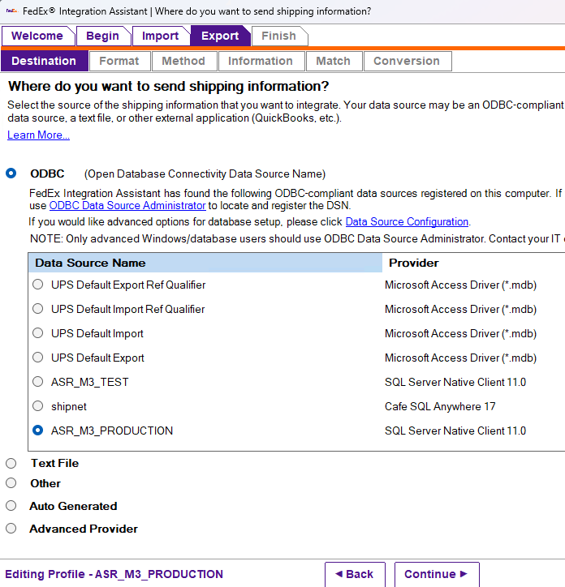

Even though we did this on the import, we need to do it again on the export.
You’ll get a message about not being able to connect, click OK and it will prompt for credentials, enter the credentials from the ODBC setup step and click Ok.
User: SM0004
Password: <Ask Development Team for Password – in Key Vault>
Setup the export to trigger as follows;
Each time a shipment is completed
Also export each time a package is deleted
Insert a new record
Include manual shipments
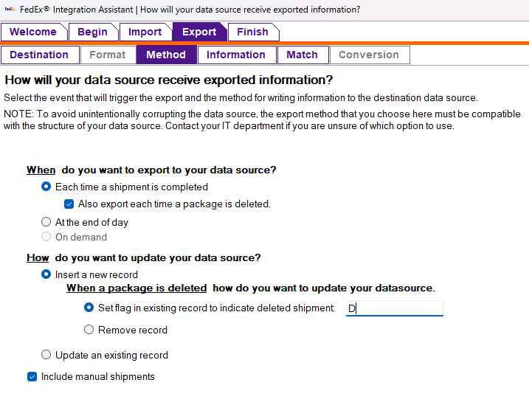

We need the following information:
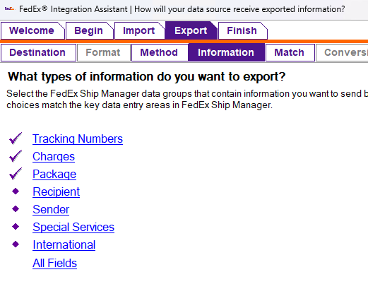
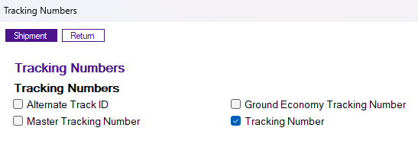
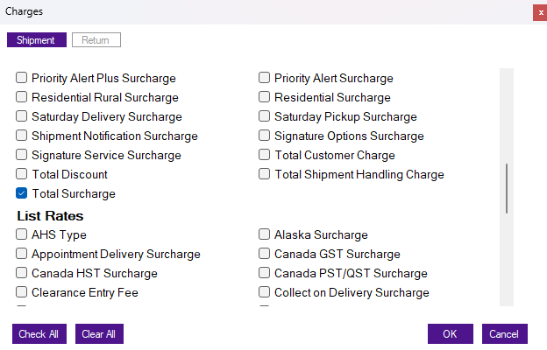
These are the only three fields on Package:
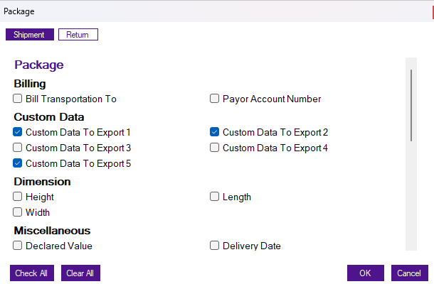

Map the export record as follows:

Pick the FedEx_Shipment table
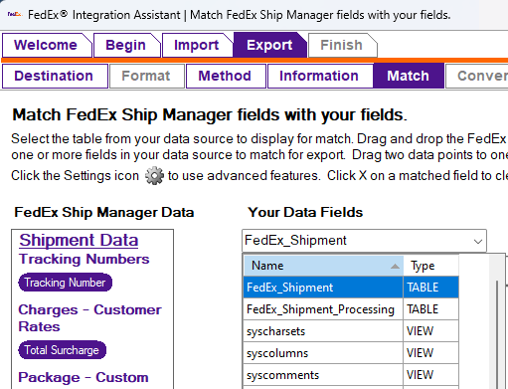

Map as follows
